  - GM600 System Architecture

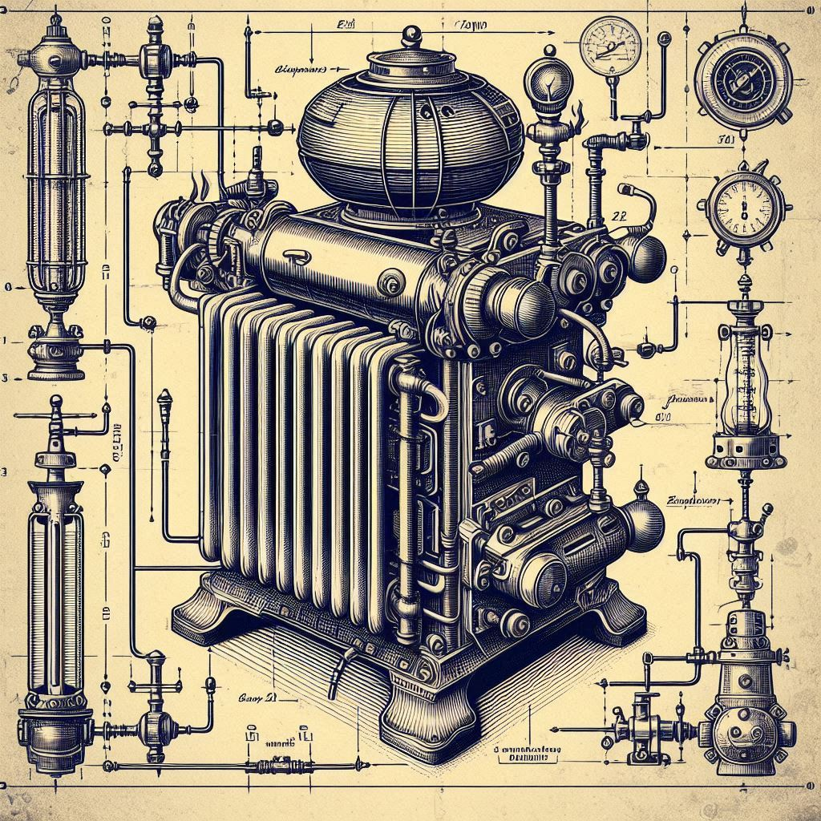

Scope
This document captures the overall System design for the GM6000 product.
The target audience for this document are the System Engineers and the various cross functional teams such as the Software Development, Hardware, Mechanical, and Quality teams. In addition, authors are required to view the audience as not only being the original team, but also future team members.

Overview
The GM6000 is a Digital Heater Controller (DHC) that can be used in many different form factors and heating capacities. The specifics of the unit’s physical attributes will be provisioned into the DHC when the final assembly of the DHC is performed.

Glossary
Term | Description
DHC | Digital Heater Controller

Document References
Document # | Document name | Version
MRS-1322 | GM6000 Marketing Requirement Specification | 0.1
PRS-1323 | GM6000 Product Requirement Specification | 0.1

Block Diagram
To meet the marketing needs of multiple form factors and capacities, the decision was made to break down the DHC unit into six major sub-assemblies (see Figure 1). The individual sub-assemblies can be specific to physical enclosures with the exception of a single Control Board sub-assembly that is common all enclosures.

The DHC system consists of the following components that will be physically located within the primary physical enclosure. There can be many different physical enclosures.
Figure 1: System Architecture Block Diagram
Component | Description
Control Board (CB) | This contains the Microcontroller that runs the heater controller. The CB contains circuits and other chips as needed to the support the MCU and software.
Display and User Inputs (DUI) | A separate board that contains the display, buttons, and LEDs used for interaction with the customer. This DUI can be located anywhere within the enclosure and is connected to the CB via a wire harness or cable.
Temperature Sensor (TS) | A thermistor is used to measure the unit’s temperature. The TS can be located anywhere within the enclosure and is connected to the CB via a wire harness or cable.  Note: Physical placement of the TS is important to overall performance of the unit. That is, it must be located (and thermally isolated) such that it can accurately measure the space temperature.
Heating Element (HE) | This is the heat source for the unit. The HE must support a Pulse Width Modulation (PWM) input signal that is used to control its variable heating capacity. The HE shall contain a temperature protection circuit that prevents the HE from exceeding the safe design limits. The details of the HE heating capacity is provisioned into the CB when the unit is manufactured. The HE can be located anywhere within the enclosure and is connected to the CB via a wire harness or cable.
Blower Assembly (BA) | The blower assembly delivers the HE’s heat output to the space. The primary components of the BA are the:  - Fan  - Fan housing  - Fan motor  The BA must support a PWM input signal that is used to control the speed of the fan motor. The details of the BA capabilities are provisioned into the CB when the unit is manufactured. The BA can be located anywhere within the enclosure and is connected to the CB via a wire harness or cable.
Power Supply (PS) | The power supply accepts line power in and is responsible for providing the appropriate voltage inputs and current ratings to the CB, HE, and BA. The PS is connected to the CB, HE, and BA via wire harnesses or cables.  Note: The DUI and the optional WM board are powered via their connection with the CB.

The following components are optional depending on the configuration of the final end product.
Component | Description
Wireless Module (WM) | This board can be attached to the unit (when manufactured) to provide a wireless connection to a remote temperature sensor. The presence or absence of the WM is provisioned into the CB when the unit is manufactured. The WM can be located anywhere within the enclosure and is connected to the CB via a wire harness or cable.
Wireless Remote Temperature Sensor (WTS) | This is a fully stand-alone component that measures space temperature and reports the temperature to the main unit via the WM.

History

Author | Description | Date | Rev
S. Rogers | Initial Draft | 5/13/2023 | 0.1

